JH2. FRANK HURLEY SERIES. [n.l. 1938]

Ph Frank Hurley
F Photograph with white margin all round, title in lower margin with each view numbered (number incorporated below)
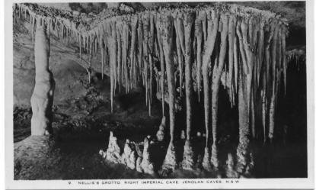

JH2.1 The Grand Arch and Lake, Jenolan Caves, N.S.W. V
JH2.2 Sunrise through the Grand Arch, Jenolan Caves, N.S.W. V
JH2.2 (sic) The Grand Arch, Jenolan Caves, N.S.W. V
JH2.3 The Grand Arch and Carlotta Arch, Jenolan Caves, N.S.W. V
JH2.4 Carlotta Arch, Jenolan Caves, N.S.W. V
JH2.5 Empress Grotto Orient Cave Jenolan Caves N.S.W. V
JH2.6 The Monoliths, Orient Cave, Jenolan Caves, N.S.W. V (s.n.a. JH2.20)
JH2.7 The Blue Lake, Jenolan Caves, N.S.W. V [pm. n.e. Dec.1941]
JH2.8 Cathedral, Lucas Cave, Jenolan Caves, N.S.W. V(s.n.a. JH2.21)
JH2.9 Nellie's Grotto, Right Imperial Cave, Jenolan Caves, N.S.W. H
JH2.10 Wallabies, Jenolan Caves, N.S.W. V [ms.7 October 1941]
JH2.11 Temple of Baal and Altar, Jenolan Caves, N.S.W. V (s.n.a. JH2.26)
JH2.12 Indian Chamber, Orient Cave, Jenolan Caves, N.S.W. V (s.n.a. JH2.19) [ms.26 Nov.1938]
JH2.13 Grand Column, River Cave, Jenolan Caves, N.S.W. V (s.n.a. JH2.16)
JH2.14 Bath of Venus, Skeleton Cave, Jenolan Caves, N.S.W. V (s.n.a. JH2.22)
JH2.16 The Canopy, Orient Cave, Jenolan Caves, N.S.W. V
JH2.17 Gem of the South, Temple of Baal, Jenolan Caves, N.S.W. V
JH2.18 Grand Arch and Roadway, Jenolan Caves, N.S.W. V
JH2.19 The Minaret, Jenolan Caves, N.S.W. V
JH2.20 The Caves House from the Drive, Jenolan Caves, N.S.W.
H [ms.31 Dec.1940]
JH2.21 Jenolan Caves House, N.S.W. H

Also one un-numbered card otherwise identical
JH2.xx The Grand Arch, Jeniolan Caves, N.S.W. H

